**Laboratory work #2**

Submission format: word or pdf document containing screenshots of your tasks with answers that covers full-page screenshots (Alt+PrtSc).

**DDL**

1. Create following tables with corresponding attributes:

* **Airline_info:** airline_id (int), airline_code (varchar (30)),airline_name (varchar(50)),airline_country(varchar(50)), created_at(timestamp), updated_at(timestamp), info(varchar(50)) ;
* **Airport**: airport_id(int), airport_name (varchar(50)),country (varchar(50)), state (varchar(50)), city(varchar(50)), created_at(timestamp), updated_at(timestamp) ;
* **Baggage_check:** baggage_check_id(int), check_result (varchar(50)), created_at(timestamp), updated_at(timestamp), booking_id(int), passenger_id(int);
* **Baggage:** baggage_id(int), weight_in_kg (decimal(4,2)), created_at(timestamp, updated_at(timestamp) , booking_id(int);
* **Boarding_pass:** boarding_pass_id(int), booking_id(int), seat (varchar(50)), boarding_time(timestamp), created_at(timestamp), updated_at(timestamp);
* **Booking_flight:** booking_flight_id(int), booking_id(int), flight_id(int), created_at(timestamp), updated_at(timestamp);
* **Booking:** booking_id(int), flight_id(int), passenger_id(int), booking_platform(varchar(50)), created_at(timestamp), updated_at(timestamp), status(varchar(50)), price(decimal(7,2));
* **Flights**: flight_id(int), sch_departure_time(timestamp), sch_arrival_time(timestamp), departing_airport_id(int), arriving_airport_id(int), departing_gate(varchar(50)), arriving_gate(varchar(50)), airline_id(int), act_departure_time(timestamp), act_arrival_time(timestamp), created_at(timestamp), updated_at(timestamp) ;
* **Passengers:** passenger_id(int), first_name(varchar(50)), last_name(varchar(50)), date_of_birth(date), gender(varchar(50)), country_of_citizenship(varchar(50)), country_of_residence(varchar(50)), passport_number(varchar(20)), created_at(timestamp), updated_at(timestamp) ;
* **Security_check**: security_check_id(int), check_result(varchar(20)), created_at(timestamp), updated_at(timestamp), passenger_id(int);

1. Define Primary Keys for each tables;
2. Define for all attributes not null constraint;

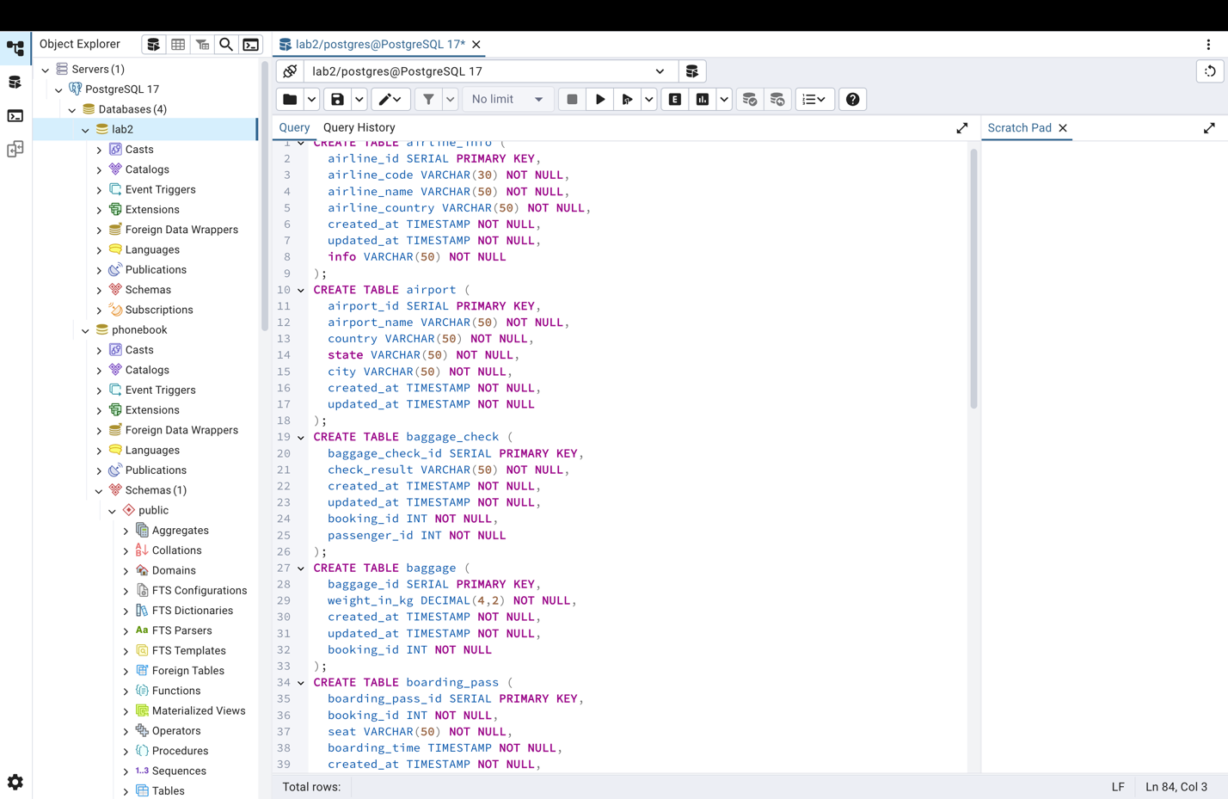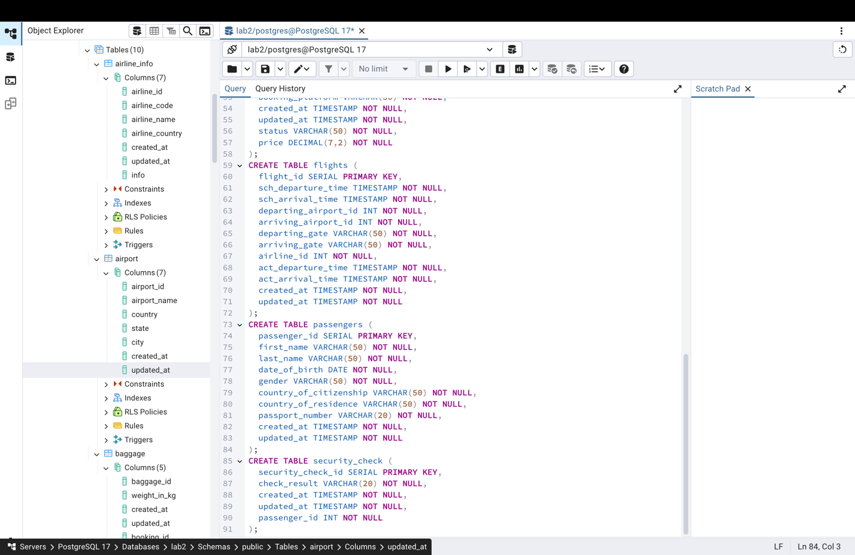

1. Rename airline_info table to  airline;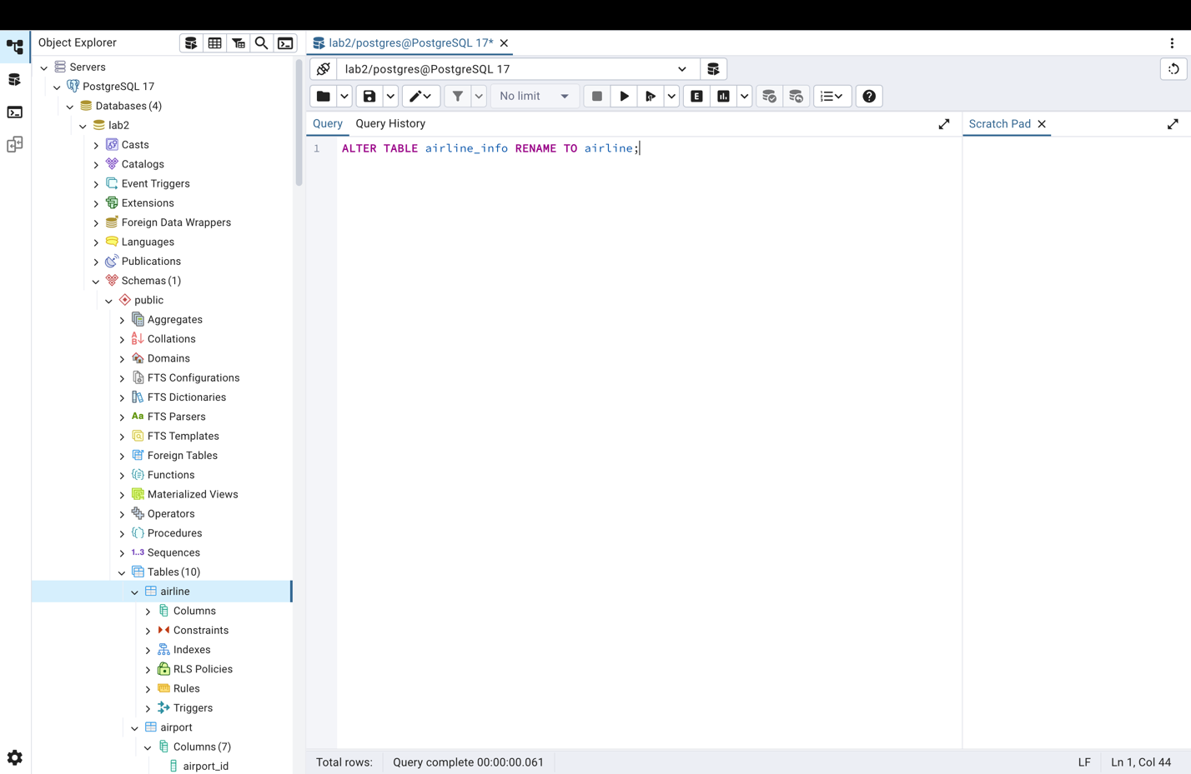
2. Rename column price  to ticket_price in booking table;

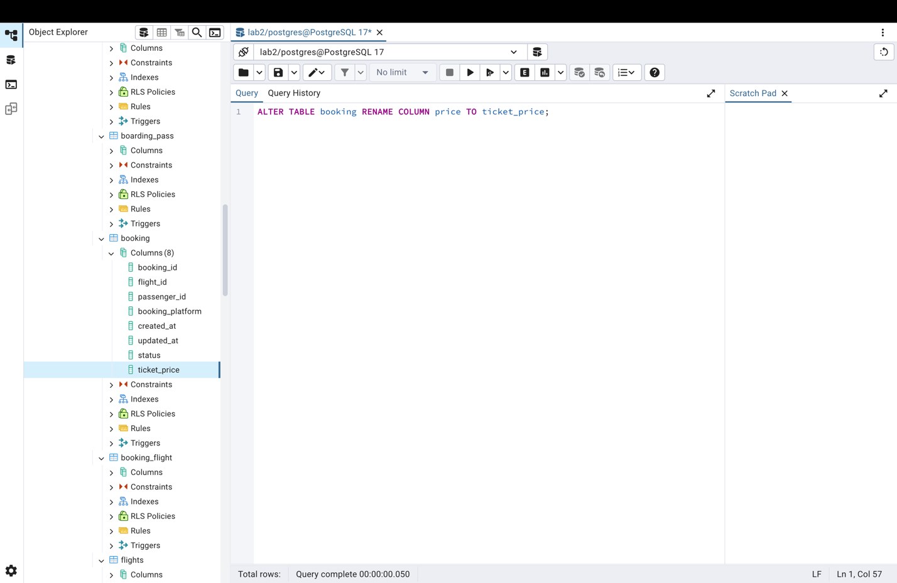

1. Change data type of departing_gate from varchar(50) to text;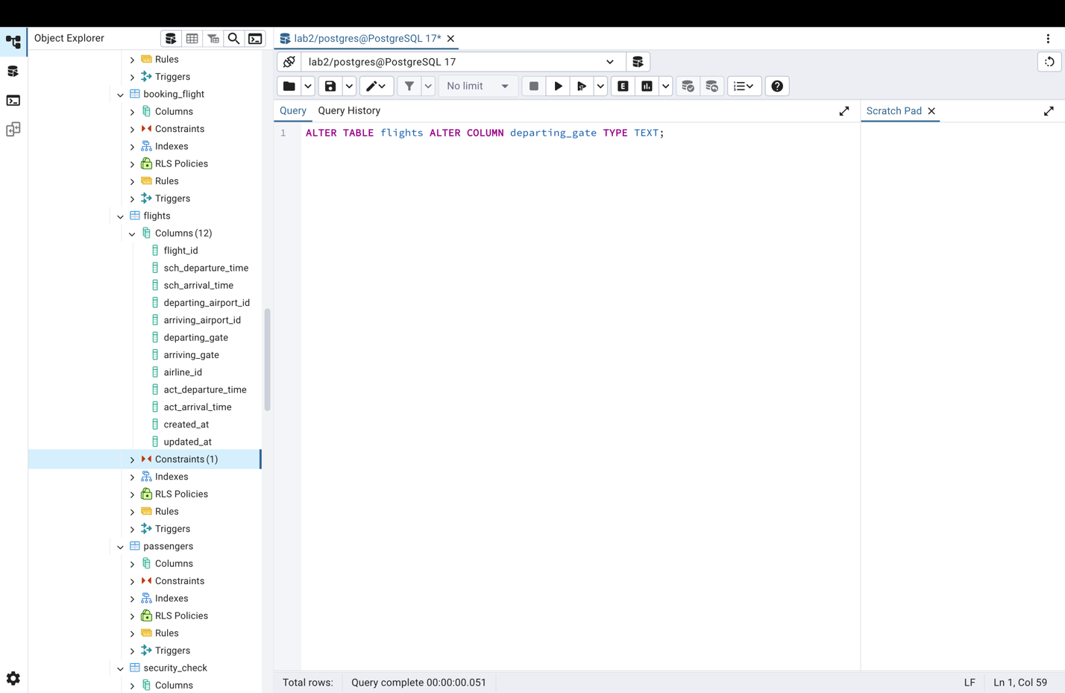
2. Drop the column info(varchar(50)) from the airline table.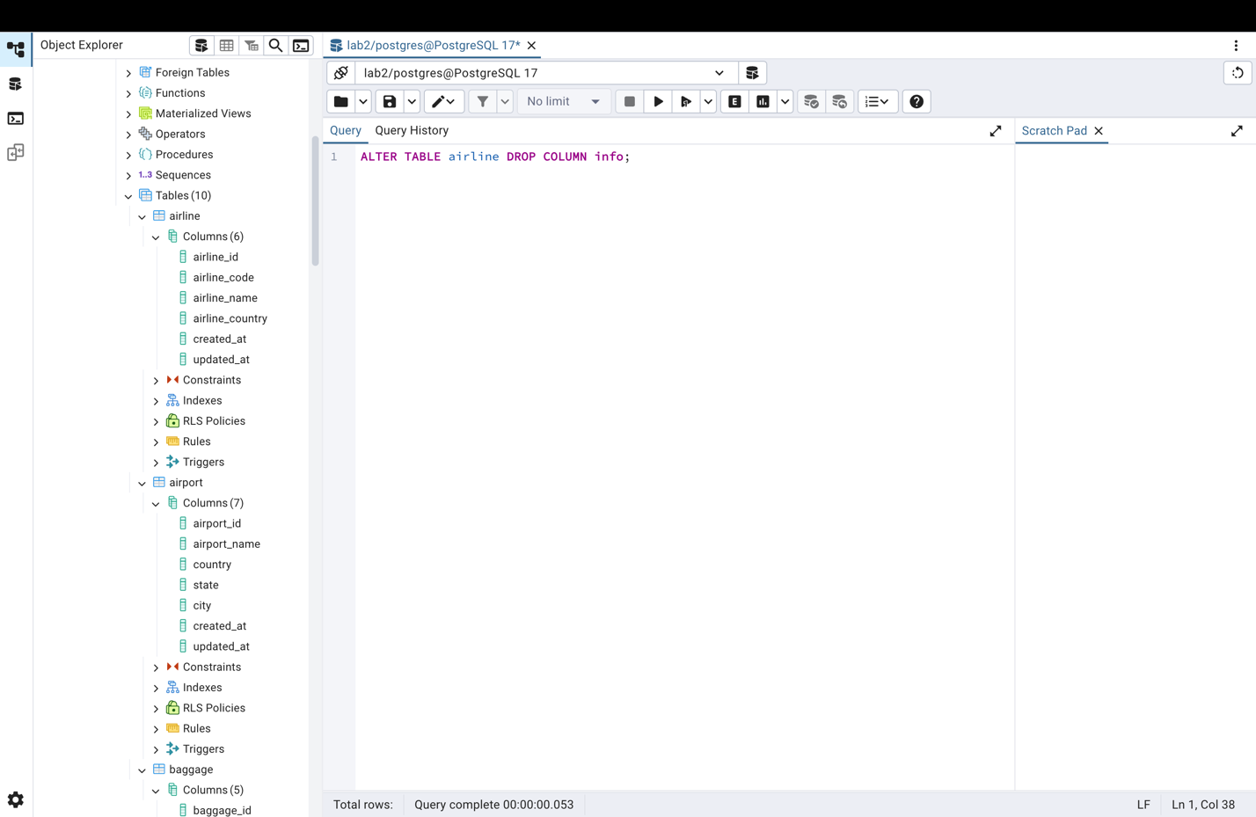
3. Make a relationship between following tables:

* Passengers with Secuitiry_check, Booking, Baggage_check by passenger_id;
* Booking with Baggage_check, Baggage, Boarding_pass, Booking_flight by booking_id;
* Flights with Booking_flight by flight_id;
* Airport with Flights by departing_airport_id;
* Airport with Flights by arriving_airport_id;
* Airline with Flights by airline_id;

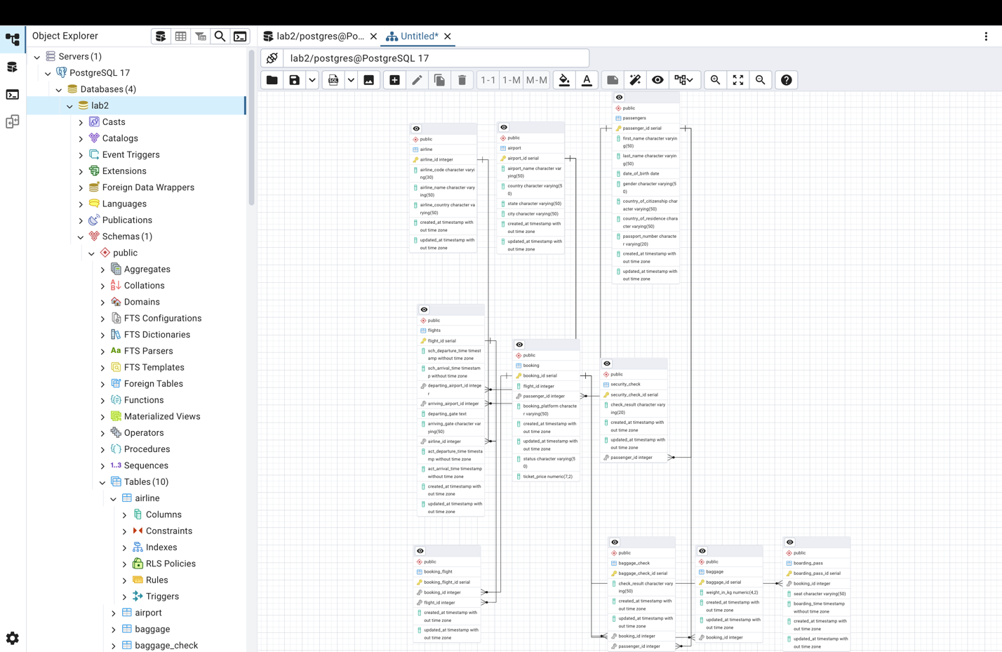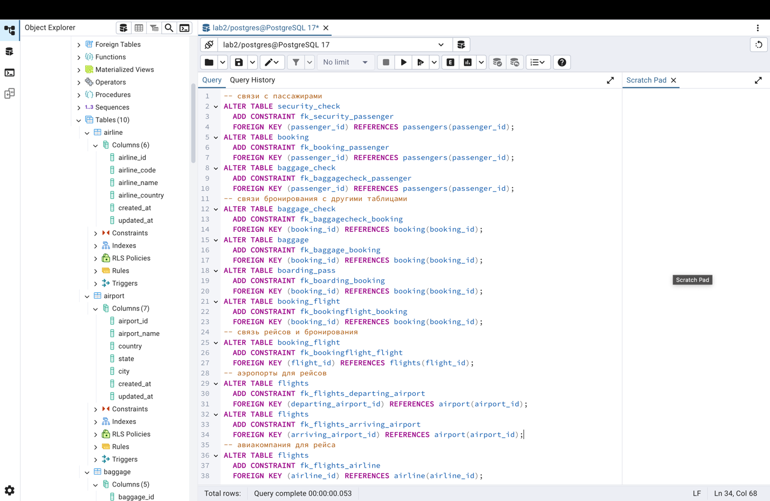

**DML**

1. Generate and insert 200 random rows in your airport database.

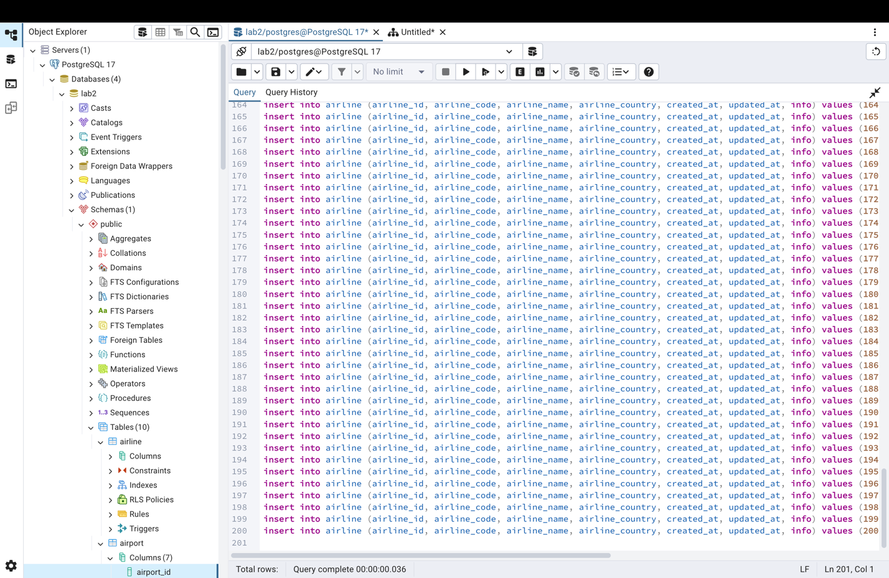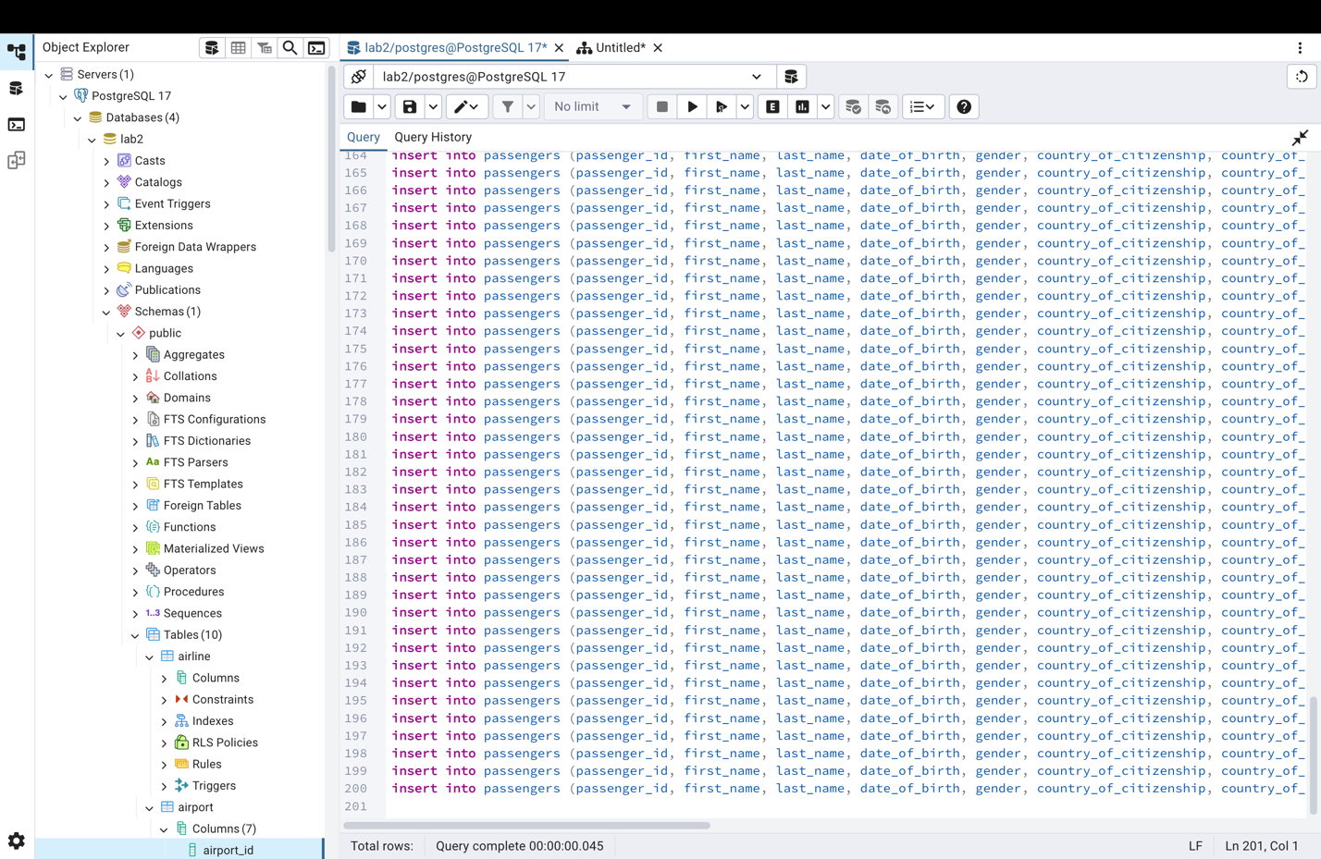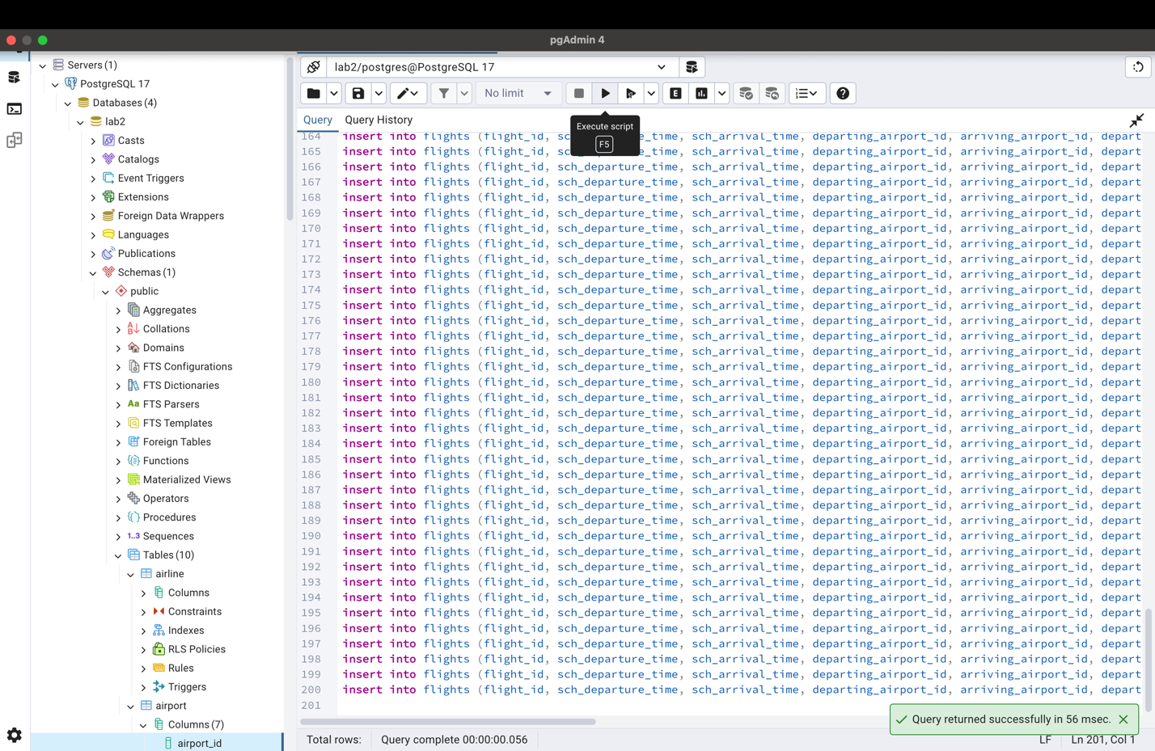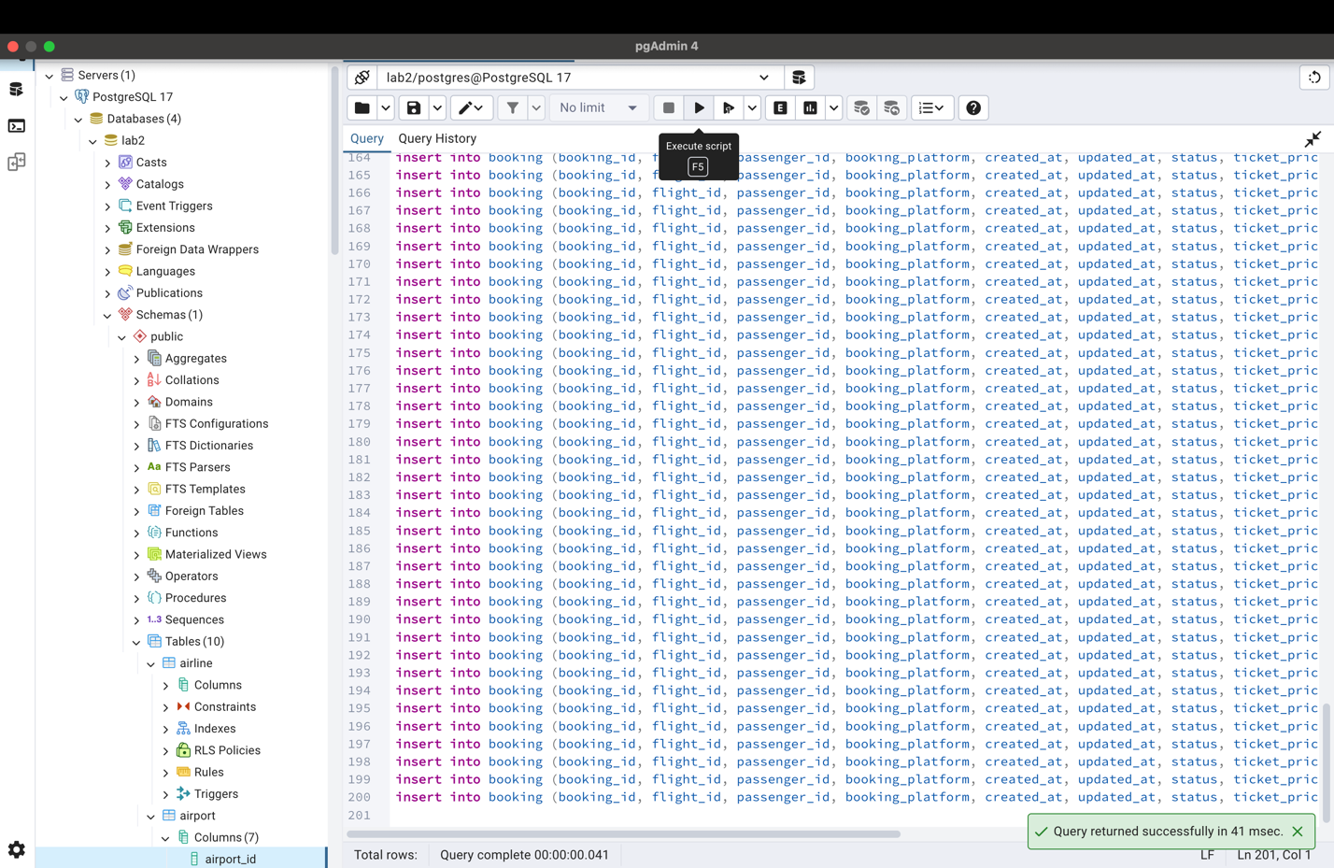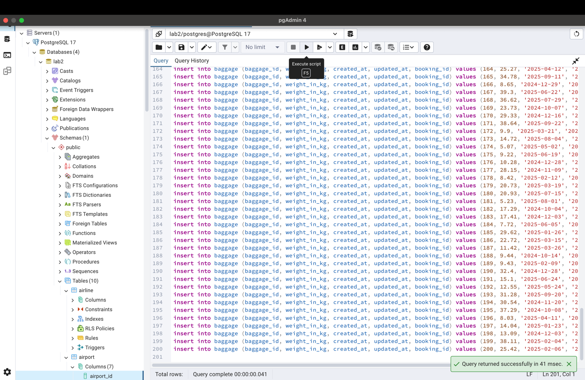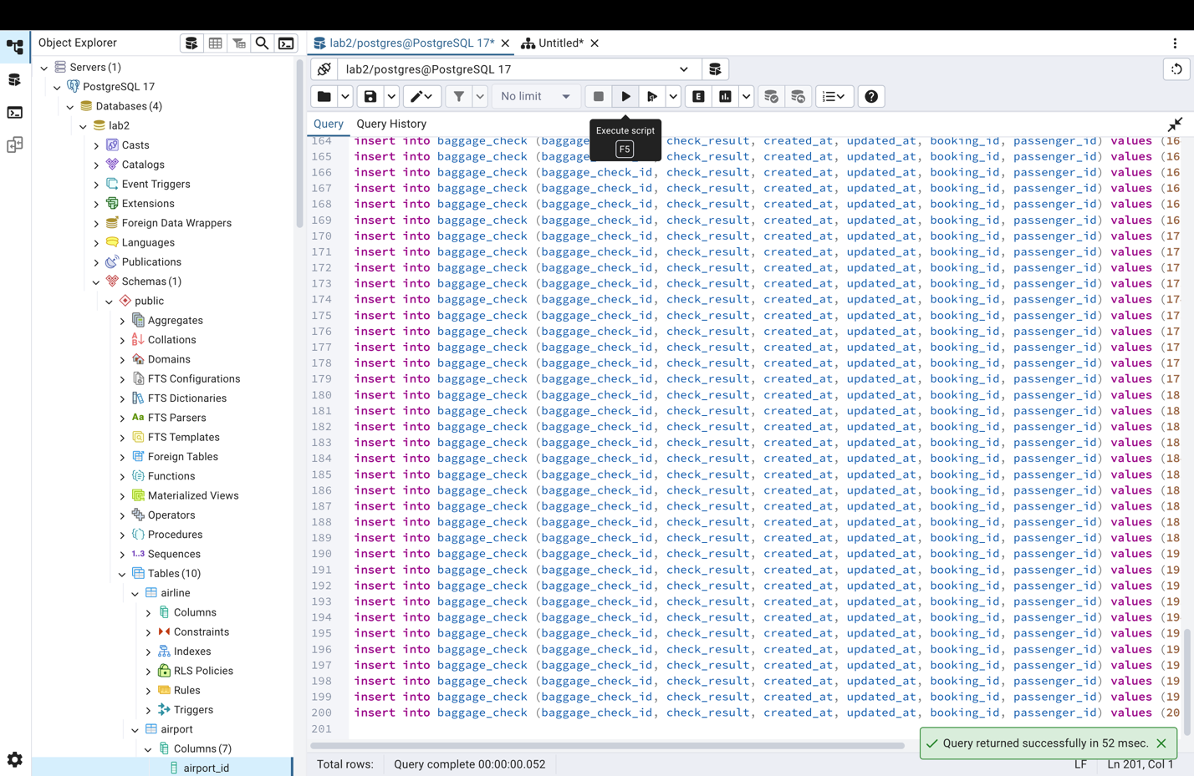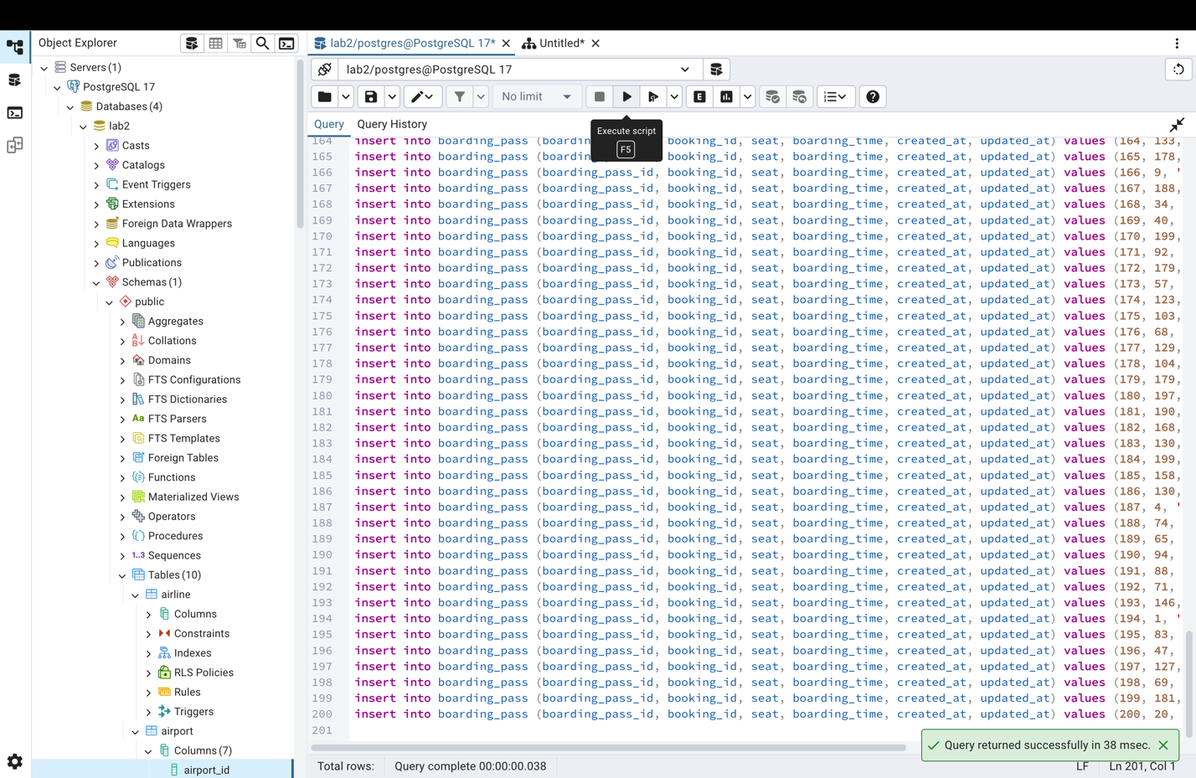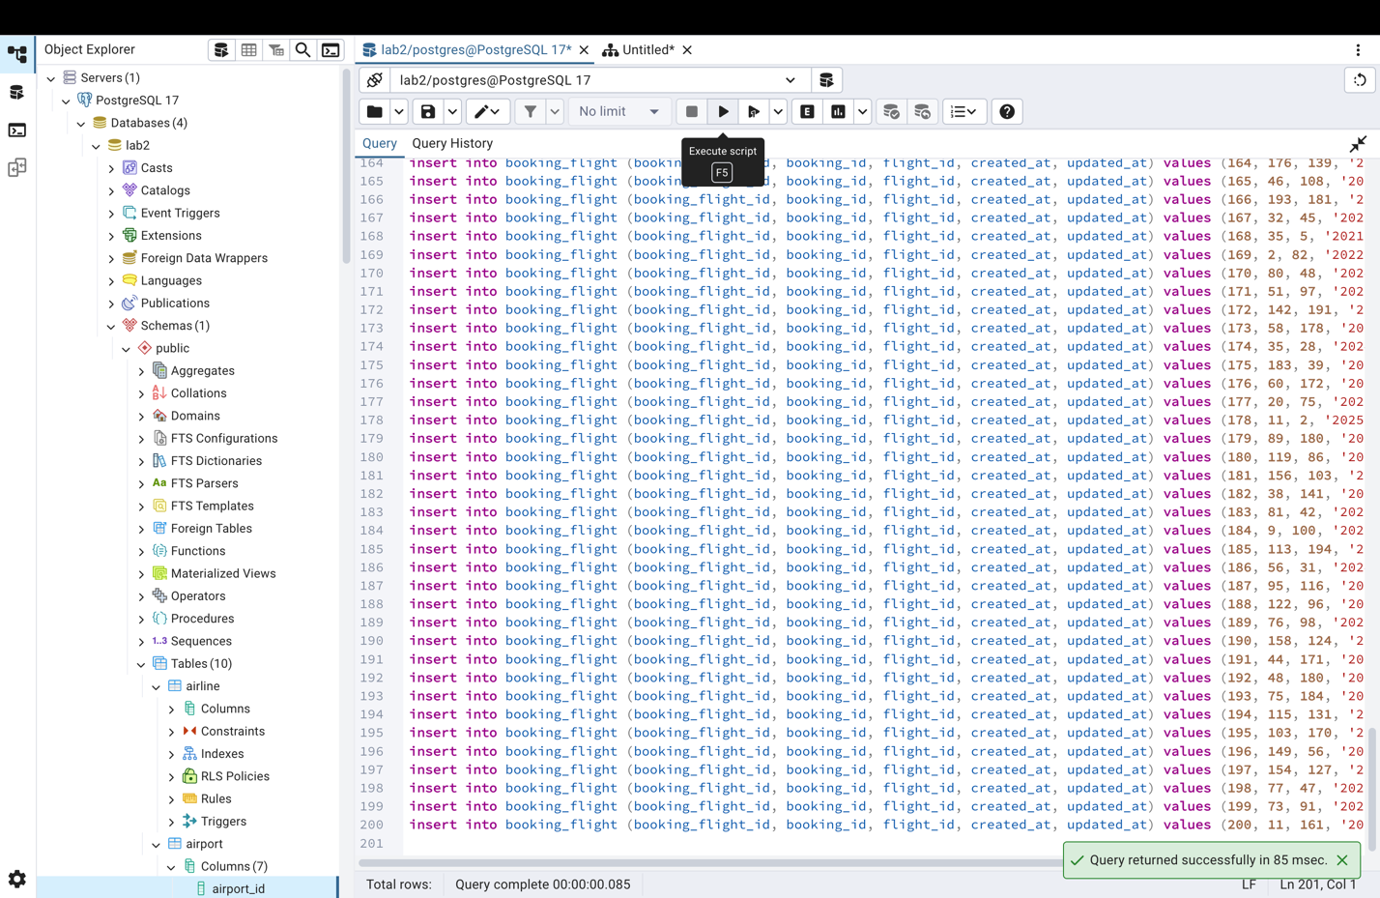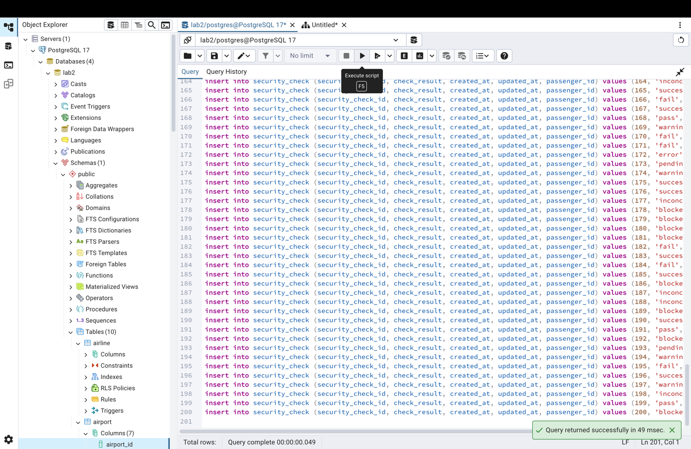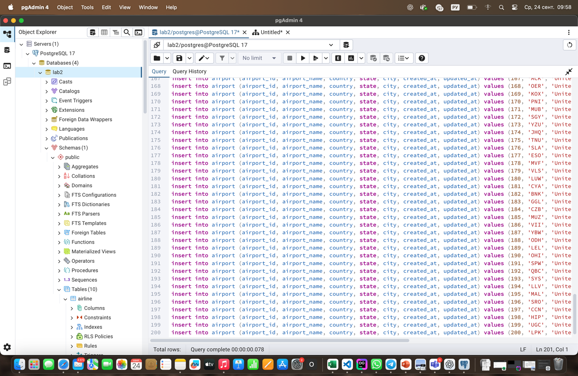

1. Add a new airline named "KazAir" based in "Kazakhstan" to the airline table.

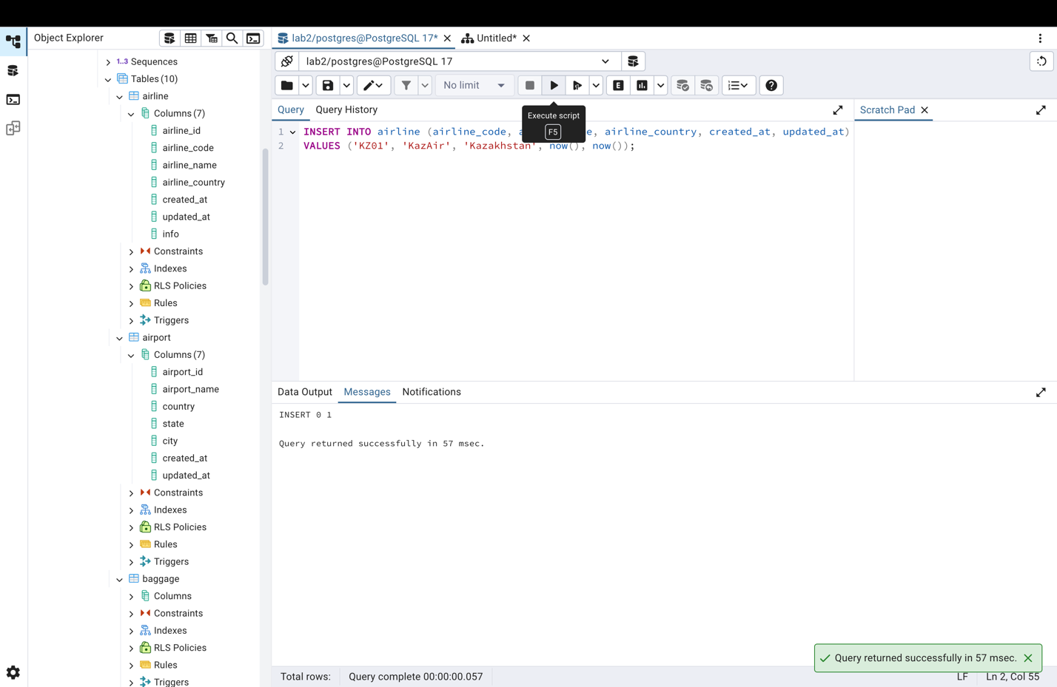

1. Update the airline country "KazAir" to "Turkey".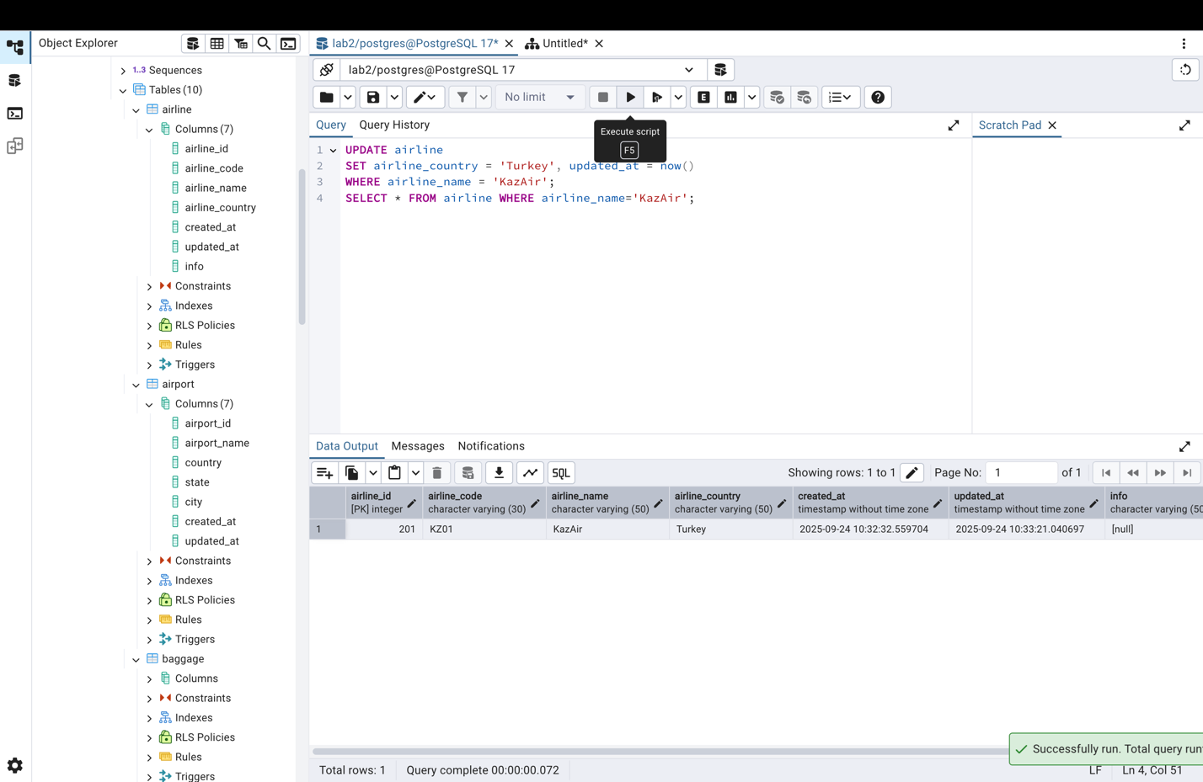
2. Add three airlines at once: "AirEasy" in "France", "FlyHigh" in "Brazil" and "FlyFly" in "Poland".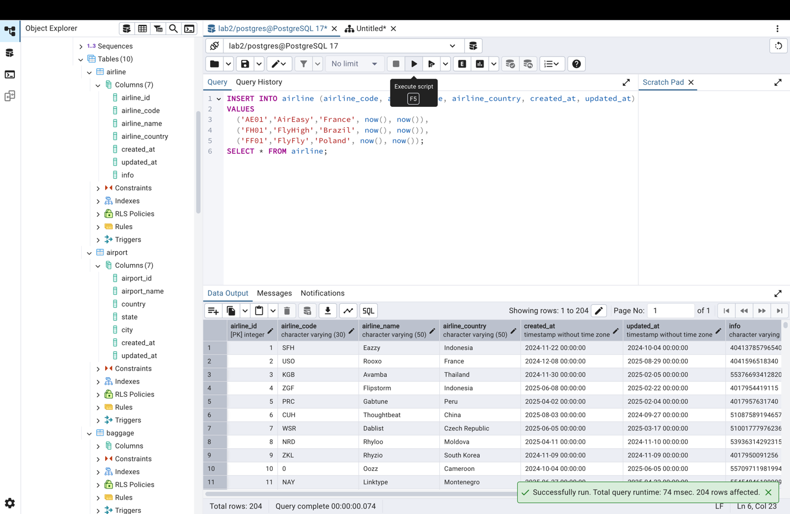
3. Delete all flights whose arrival in 2024 year.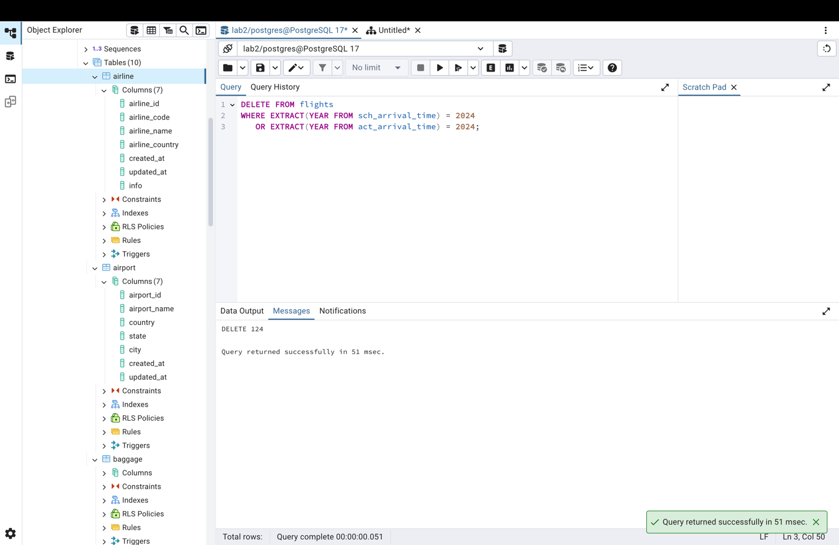
4. Increase the price of all tickets in booking table for flights by 15%.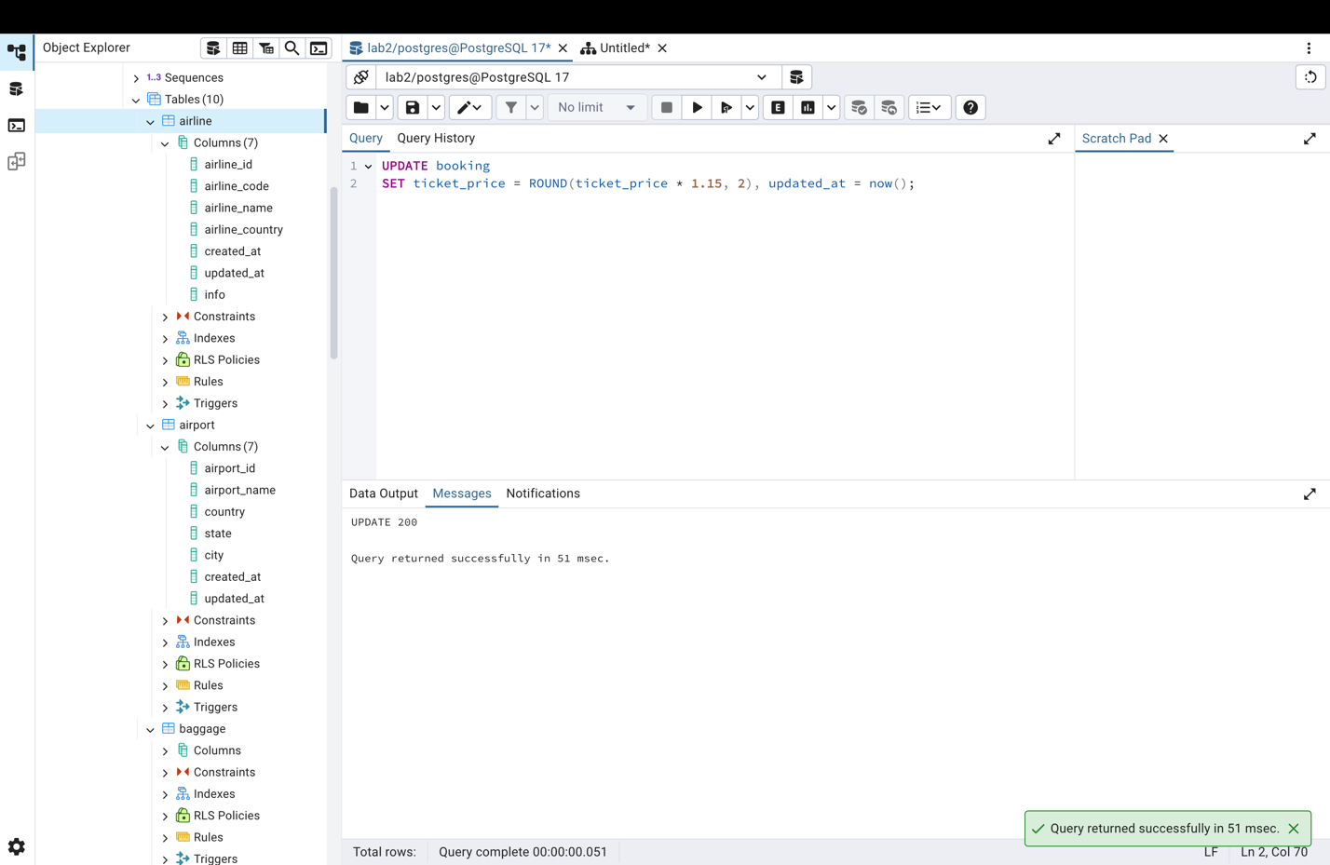
5. Delete all tickets where price is less than 10000.

